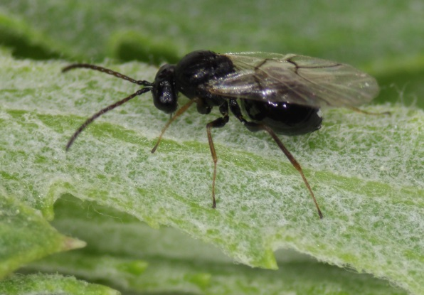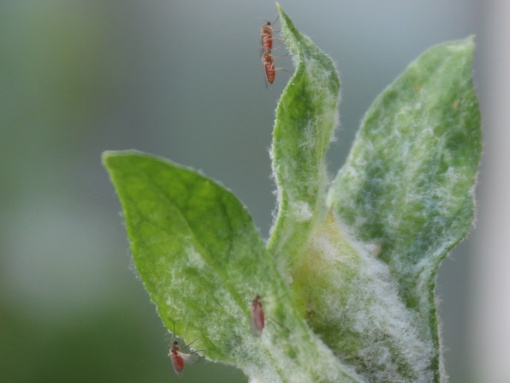
Aulacidea acroptilonica (RK gall wasp) Jaapiella ivannikovi (RK gall midge)

Biological Control of Russian knapweed (Rhaponticum repens)
There are two gall forming insects that are being used as biocontrol agents for Russian knapweed in North America. One is a gall-forming wasp Aulacidea acroptilonica (family Cynipidae) which lays eggs in developing stems causing them to swell and in some cases become severely deformed. The other agent is the gall forming midge Jaapiella ivannikovi (family Cecidomyiidae) which lay eggs at the growing shoot tips of the weed and cause the growing tips to cease elongating and to produce leaves which remain folded, forming layered galls at the growing tips.
The gall midge is currently available and has been widely released in Colorado while the gall forming wasp remains in short supply due to the fact that it has only a single generation per season which makes it difficult to rear.
Releasing the gall-forming insects
Both the fly and wasp oviposit on plants that are growing, which makes spring the best time for release. The wasp prefers laying eggs in stems just behind the growing shoot tips and the fly lays eggs around and in the growing shoot tips. This means that by summer, when plants have stopped growing, there are few if any suitable oviposition sites for the insects. One exception is in areas where Russian knapweed has been mowed or cut. If knapweed is mowed or cut and if there is sufficient moisture to enable growth, plants will send up new shoots and again become susceptible to attack by both insect species.

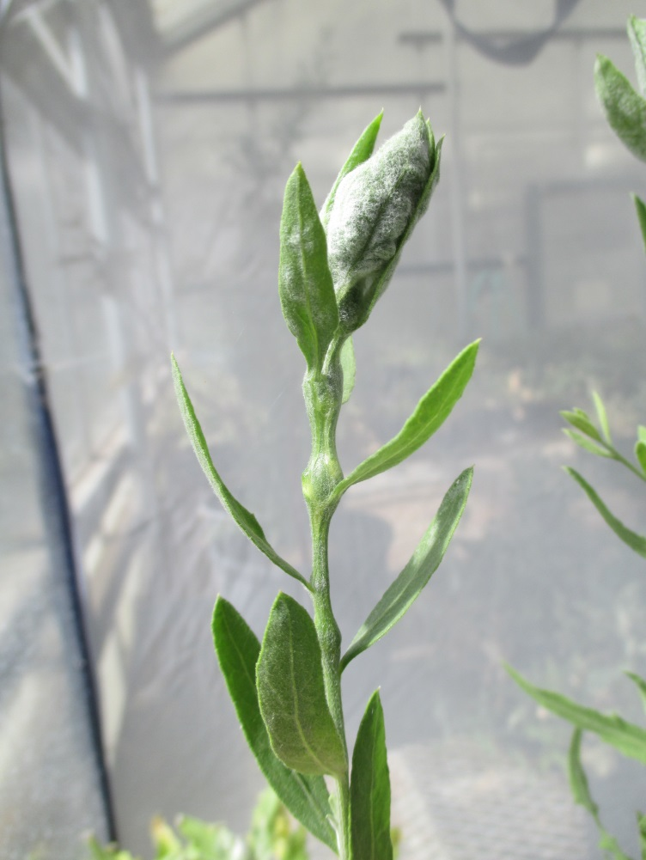
Galls of both J. ivannikovi (at the tip of the stem) and A. acroptilonica (the swellings along the stem) found on a single plant.

For more information please contact Joel Price (joel.price@state.co.us) or Dan Bean (dan.bean@state.co.us) at the Palisade Insectary. Our phone is (970) 464-7916.
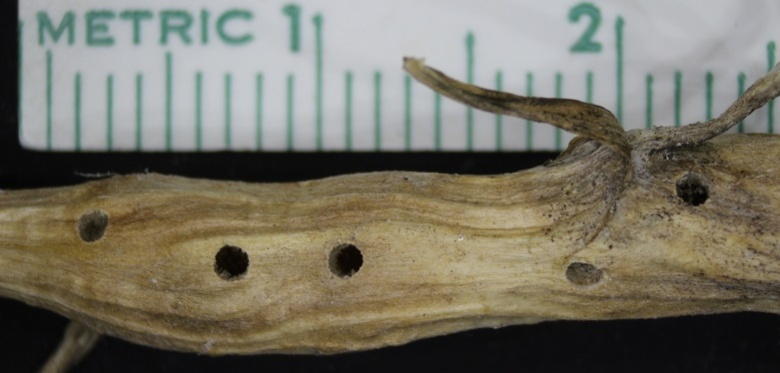
Emergence holes in a gall formed by A. acroptilonica

